MINI PROJECT

CMPE 272 – Team 23

**Movie Natural Language Classifier**

**Submitted By:**

Poojitha Reddy Eragamreddy

Syed Imran Ahmed

Shruthi Kulai

Niveditha Bhandary

**ABSTRACT:**

The project is a demonstration of how to build a Bluemix application that interacts with Watson through Natural Language Classifier service. The application allows users to enter movie name, and get the rating for the movie predicted by Watson.

Before Watson can give rating, it must be trained to have information from which it can predict correct rating. We used sample IMDB movie data to train Watson Natural Language Classifier.

We have used Node red to wire the web application with the Natural language classifier.

**BoilerPlate used:** Node Red Starter

**Service used:** Watson Natural Language Classifier

**Git Repository Link:** <https://hub.jazz.net/git/poojitha17/Movie-Natural.language.classifier>

**Web Application Link:** <http://movie-natural-language-classifier.mybluemix.net/movies/>

**IMPLEMENTATION STEPS:**

## **Step 1. Set up the Bluemix services:**

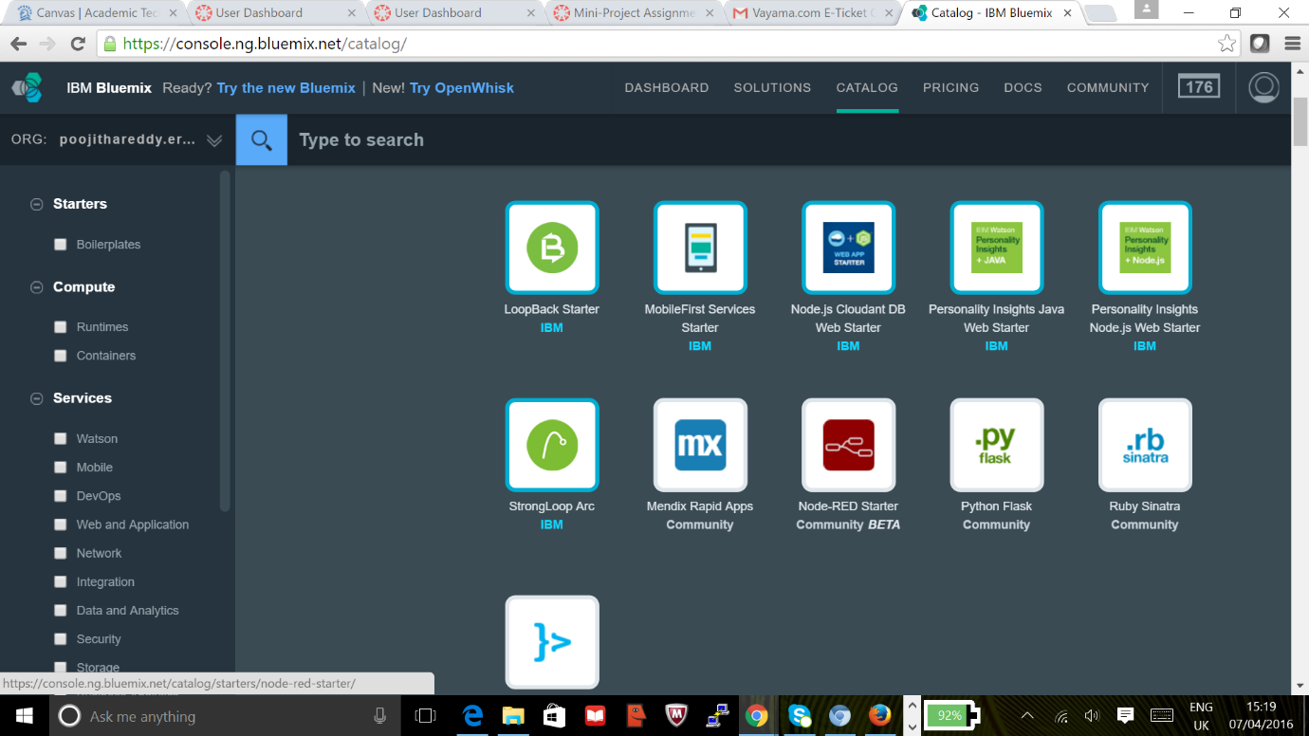

## **Step 2. Create Project with Node-Red Starter BoilerPlate:**

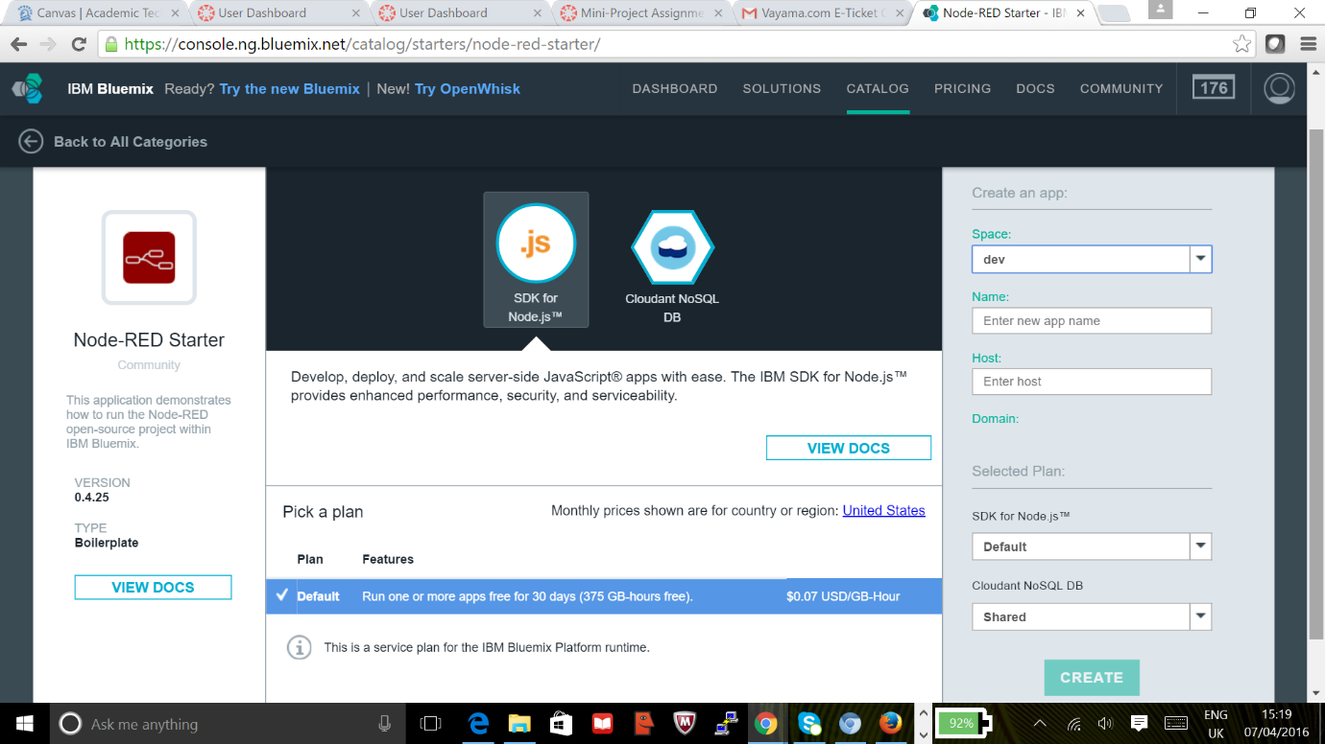

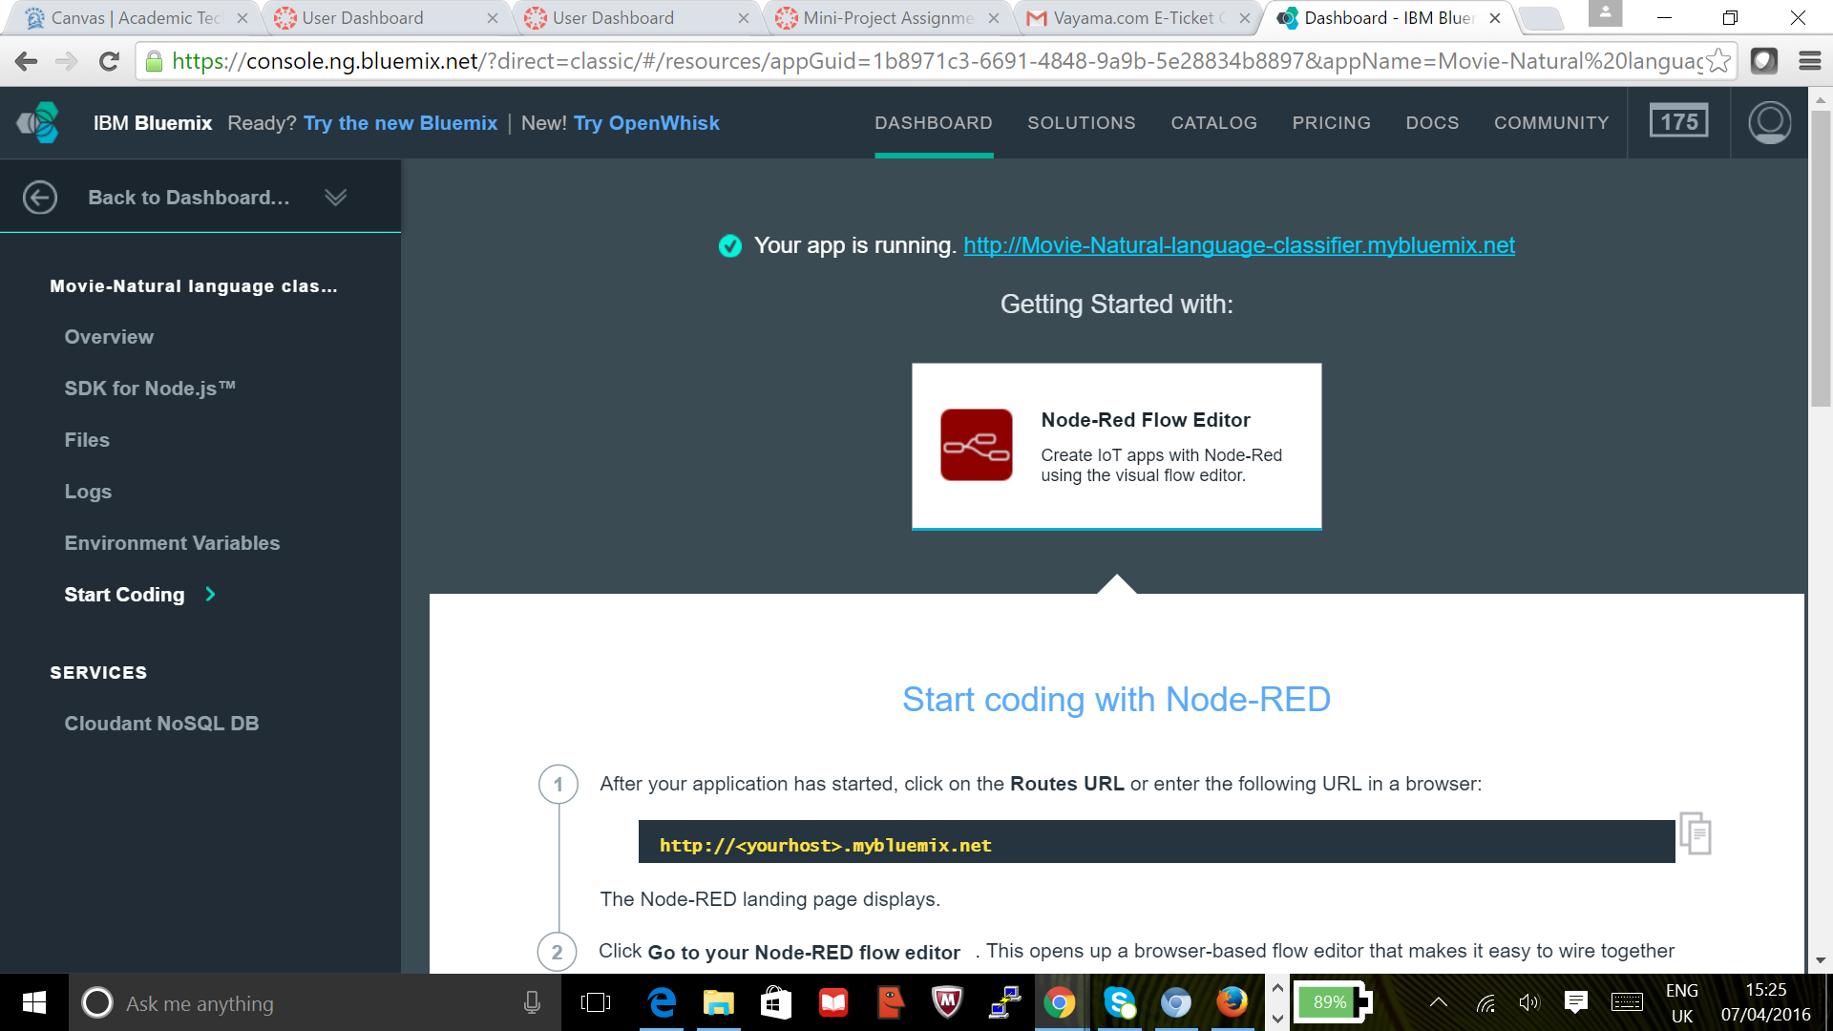

## **Step 3. Add Watson service Natural Language Classifier to the Project:**

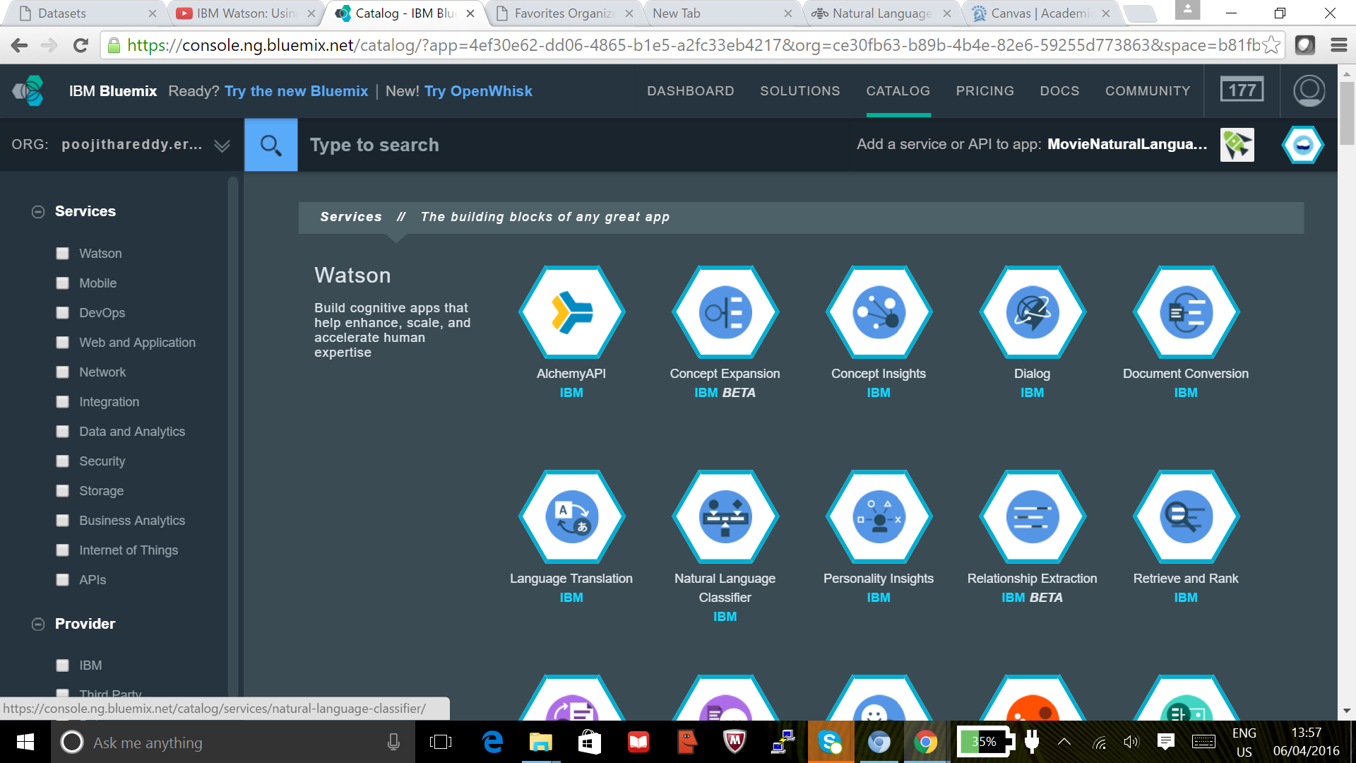

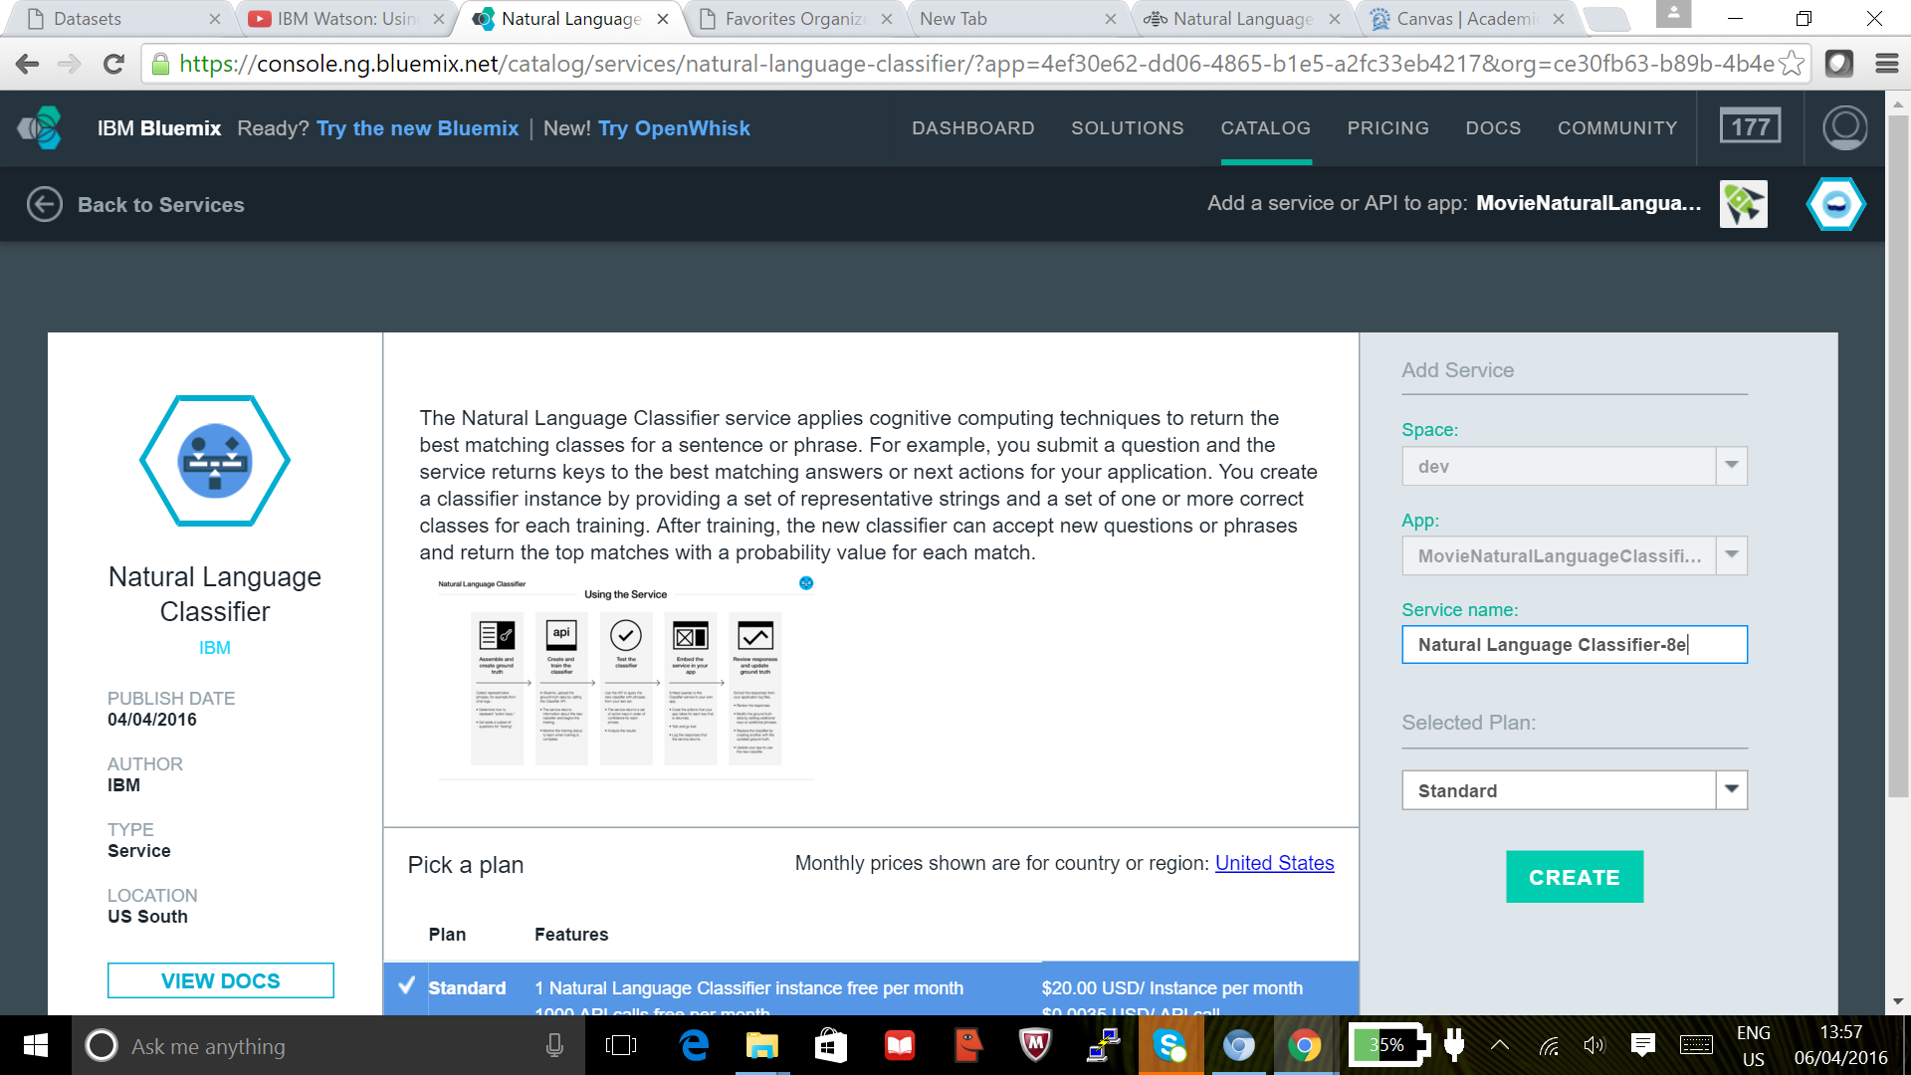

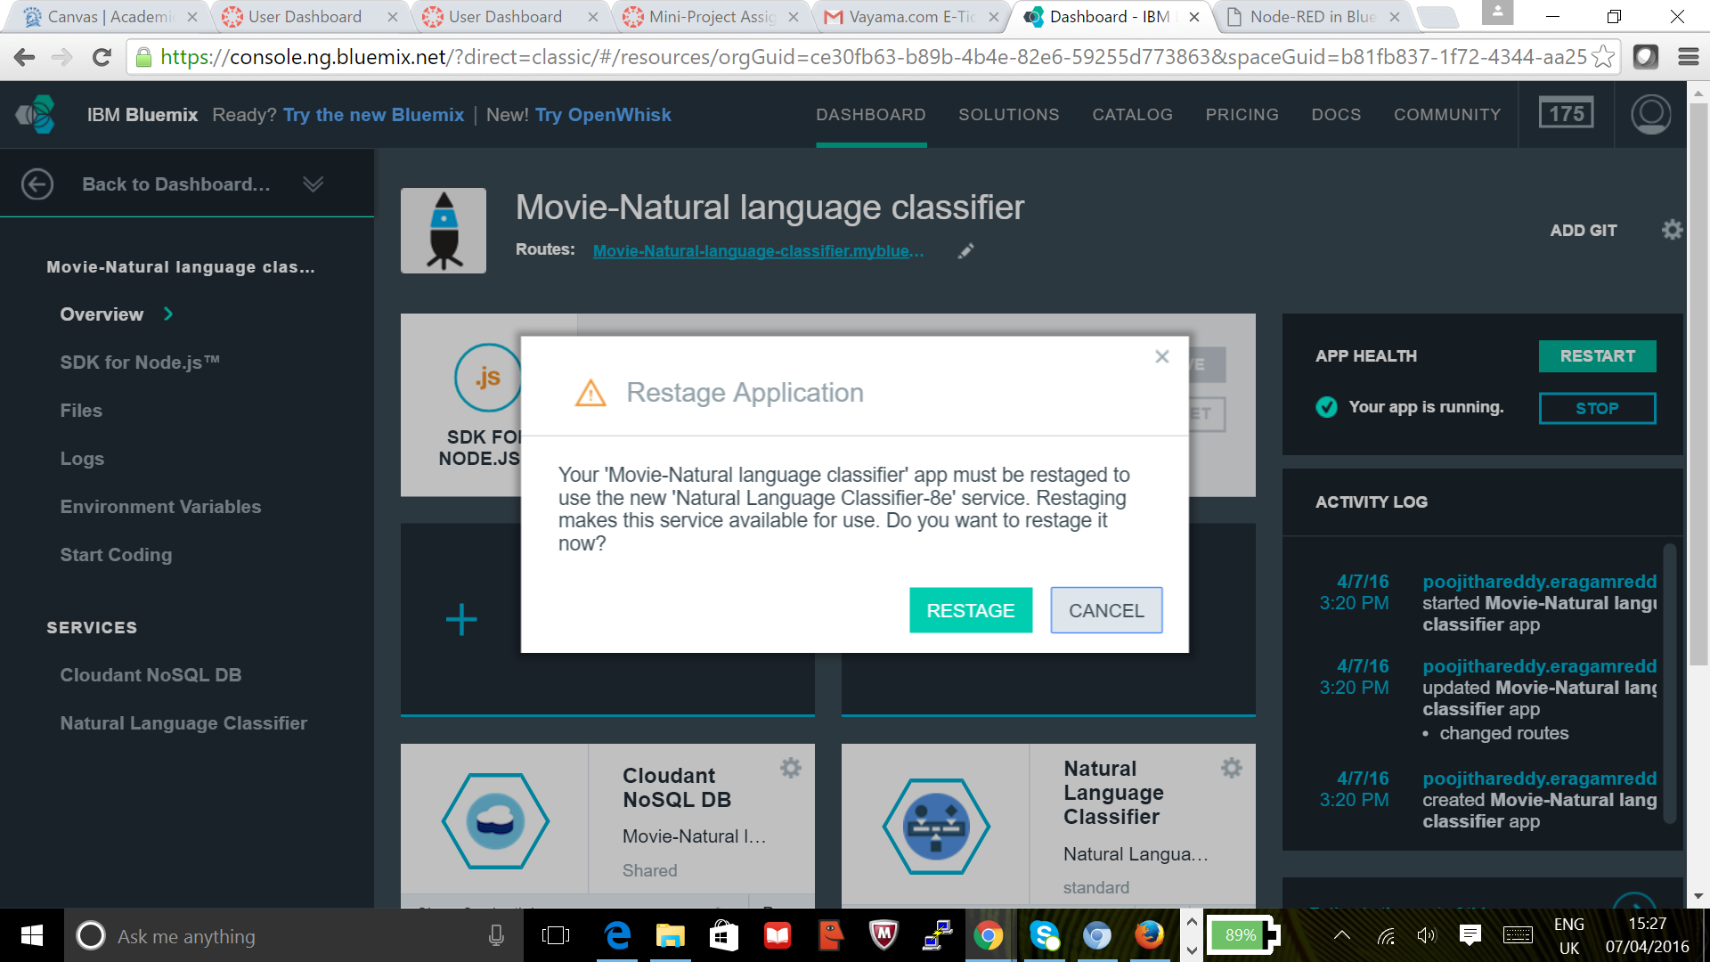

## **Step 3. Create and train classifier using sample dataset and curl commands:**

We trained the natural language classifier using a sample movie rating data set.

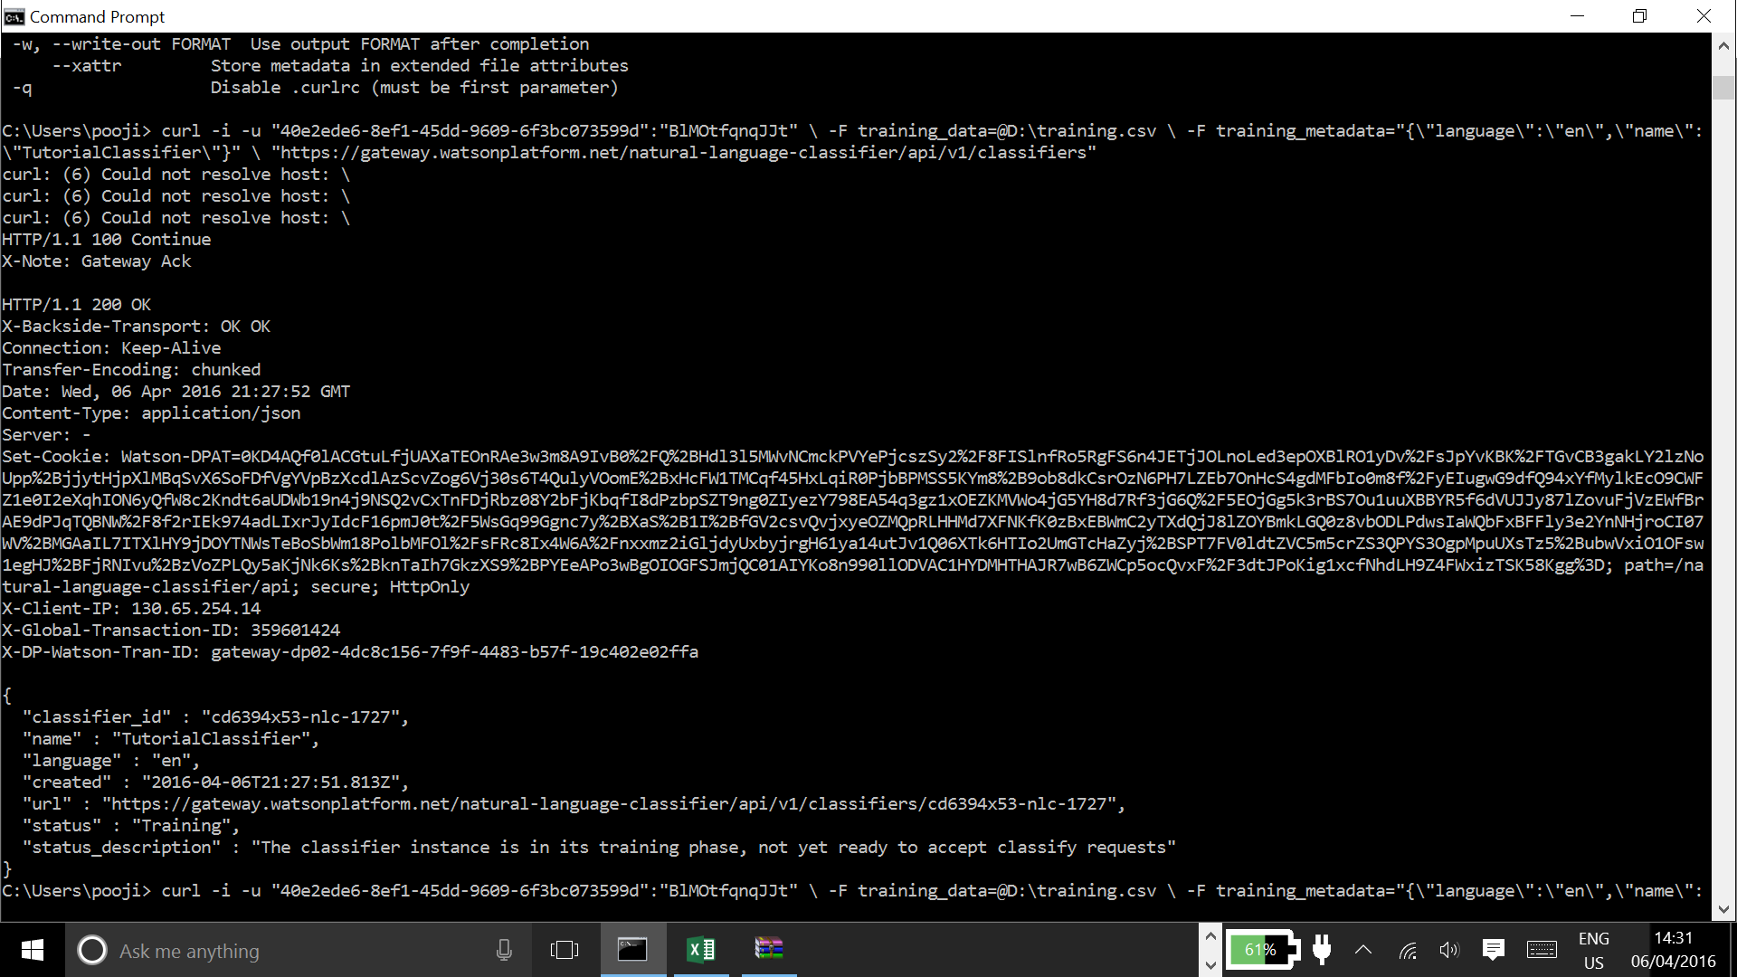

Check the training status periodically until you see a status of available, it will usually take lot of time, and can be left overnight, it took almost 6.5hrs for training the data.

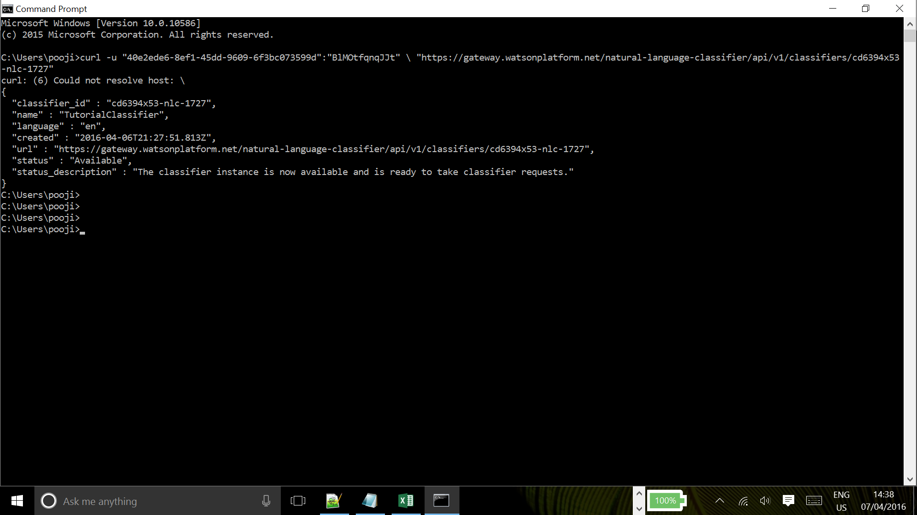

Once the classifier is trained we can again query and see, now this will give us the result with the confidence level for each class, and with the highest class number, which will be our rating for the movie.

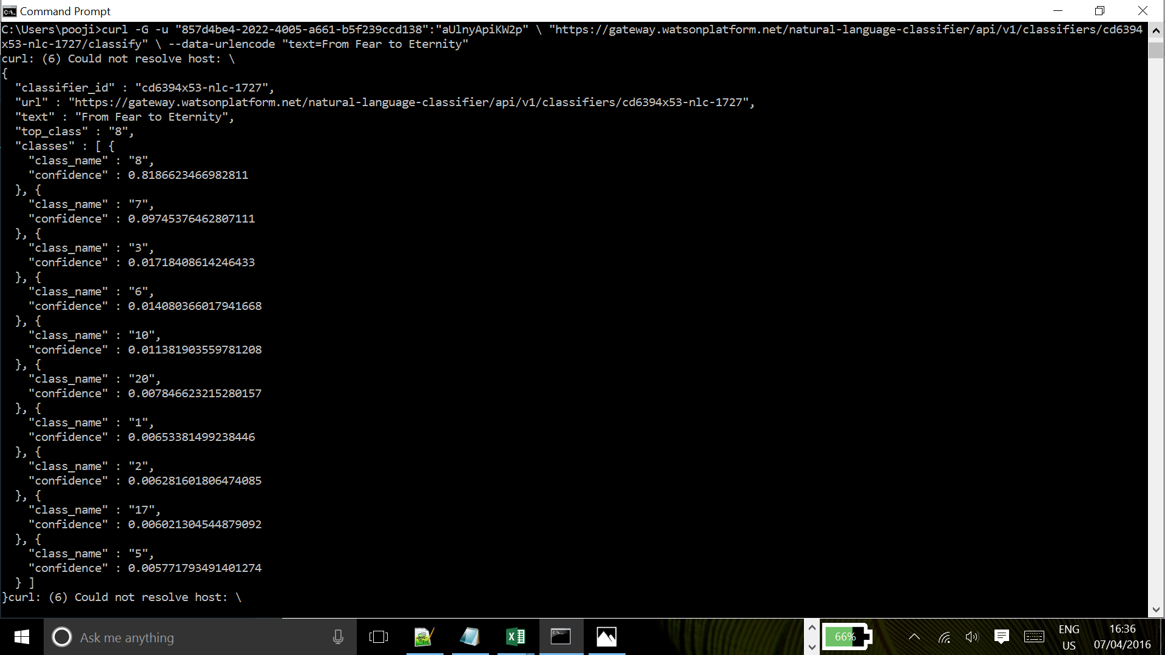

## **Step 4: Build the REST machine translation flow in Node-RED**

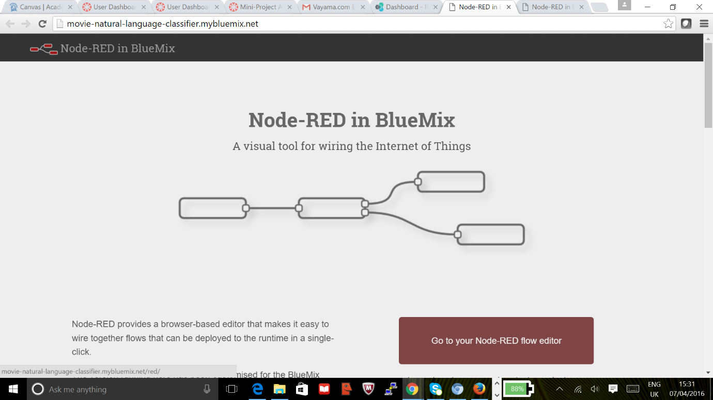

**Node Red Data Flow:**

The HTTP Input Request node receives the movie name entered in the web application. The movie name is then given to the natural language classifier function, which predicts the movie rating. The results are then posted to the web application using another HTTP node.

4.1 Inserting input HTTP request node to get the movie title:

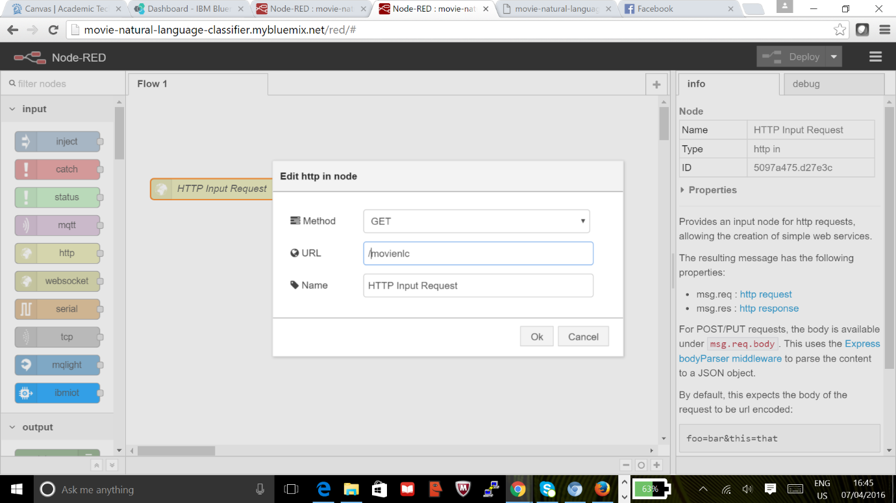

4.2 Inserting Natural Language classifier node with previously generated classifier ID:

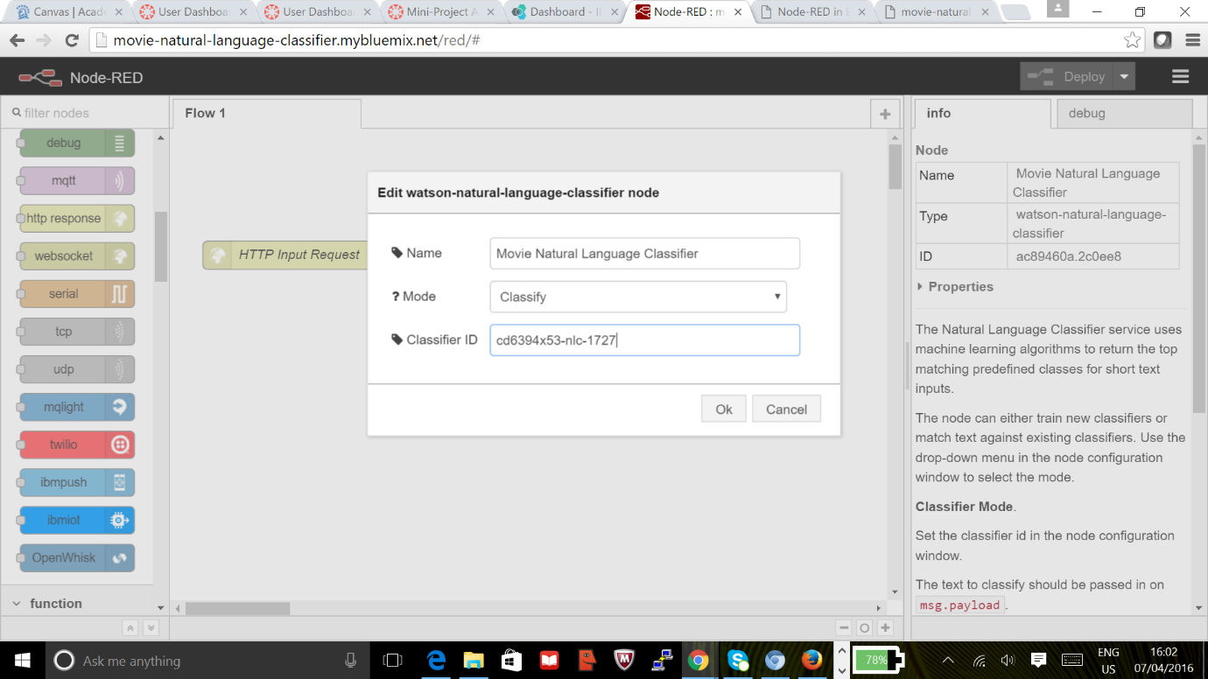

The completed flow in Node-RED looks like this:

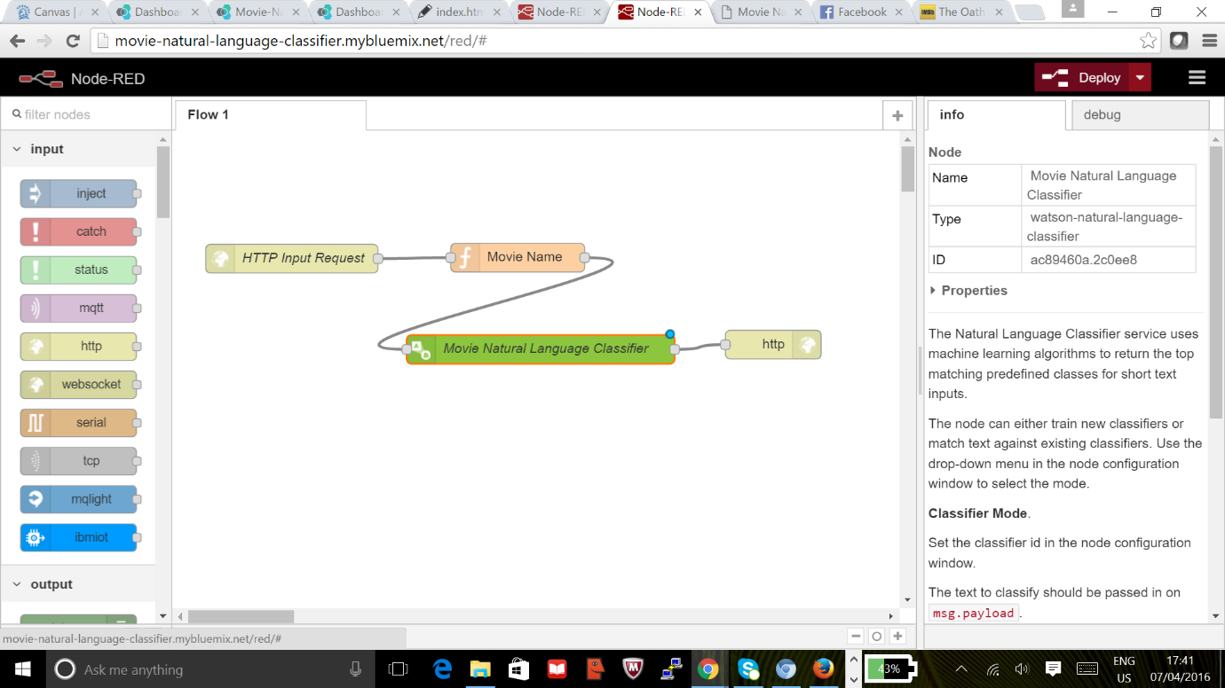

Console output in JSON format:

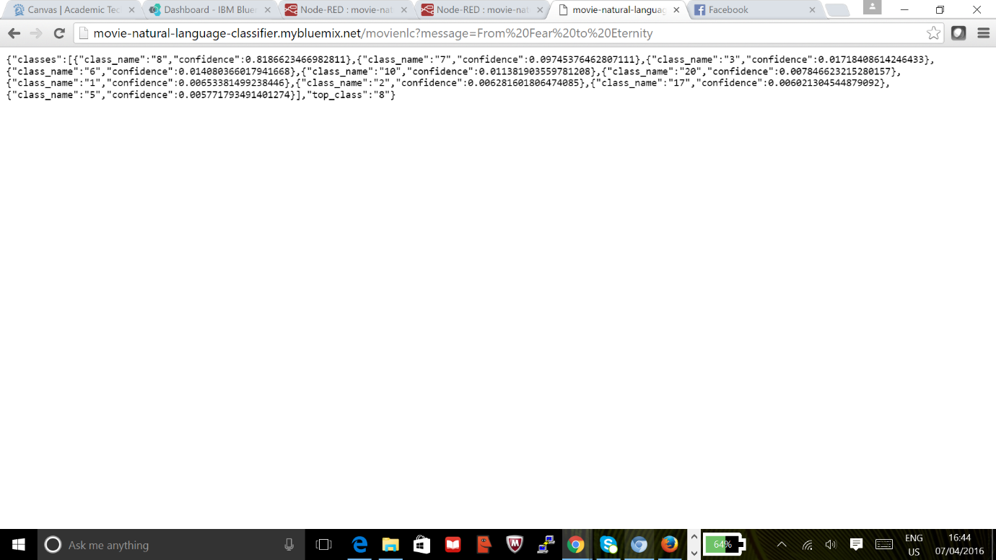

Building the UI to receive the movie name and to show the output along with the confidence level. We have used the angular js for two-way binding and showing the result.

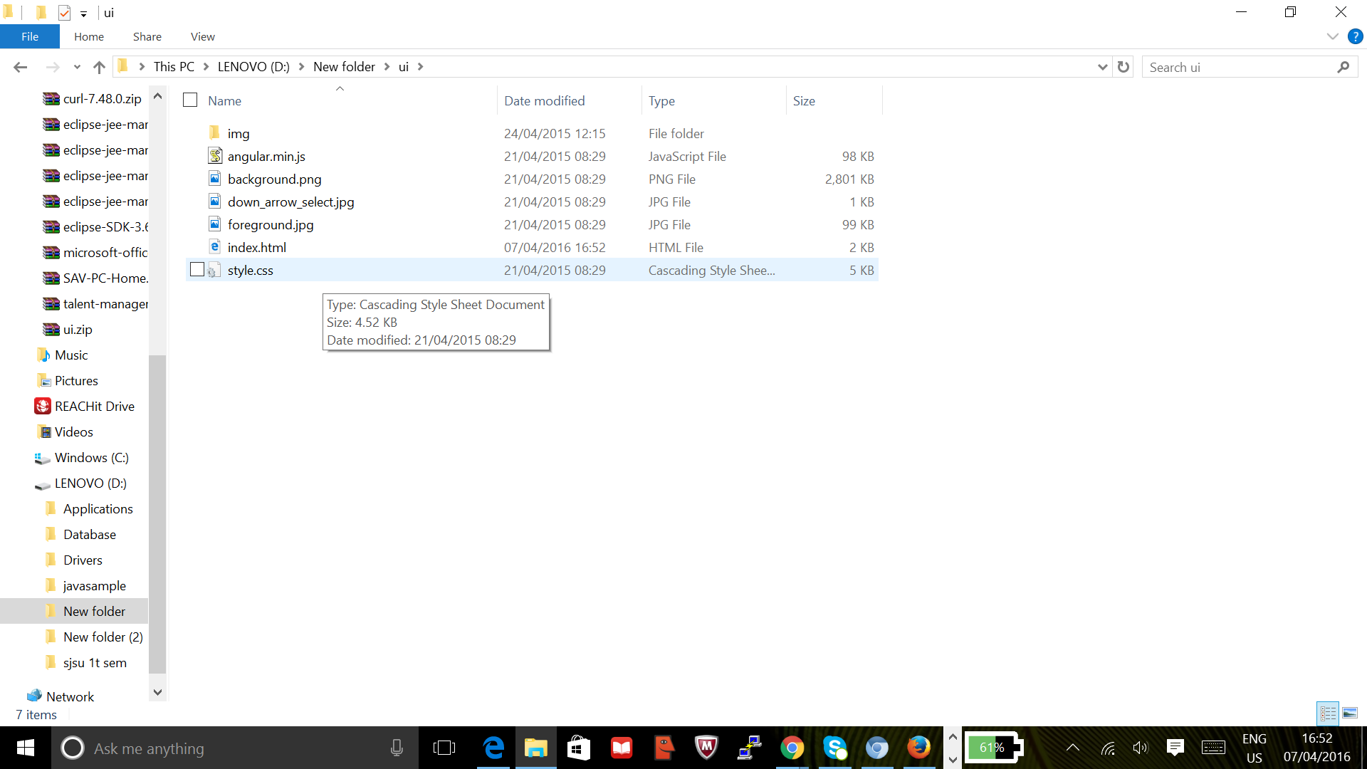

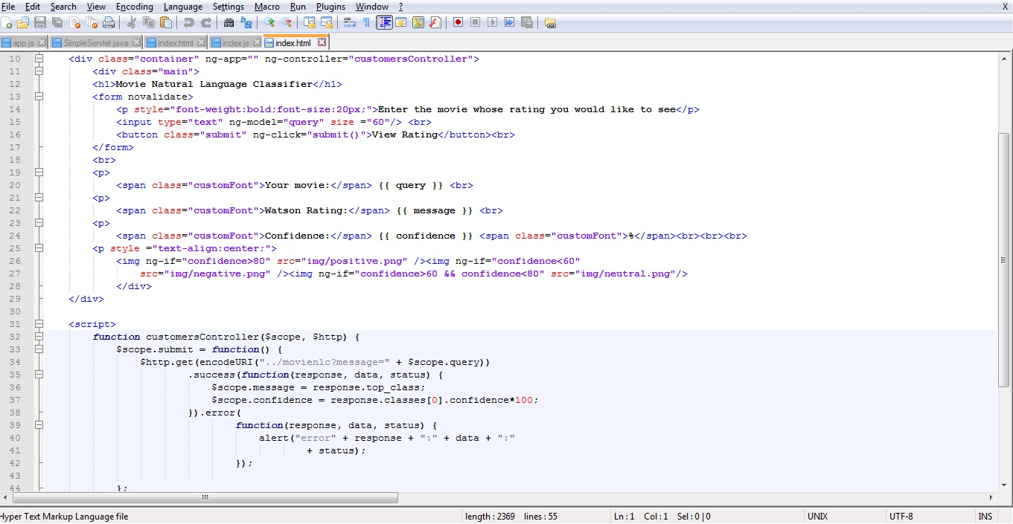

**Step 5: Create git repository**

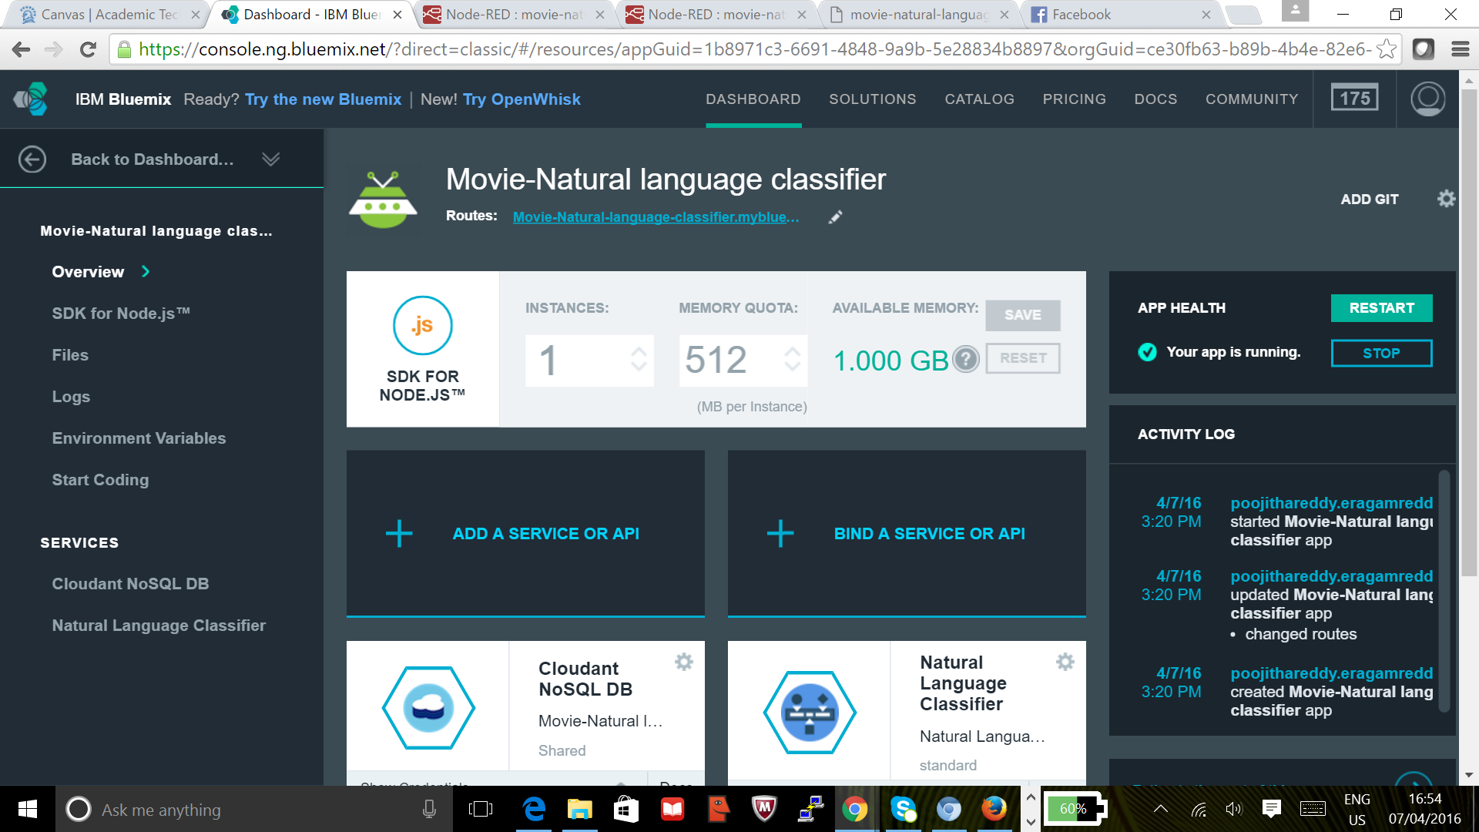

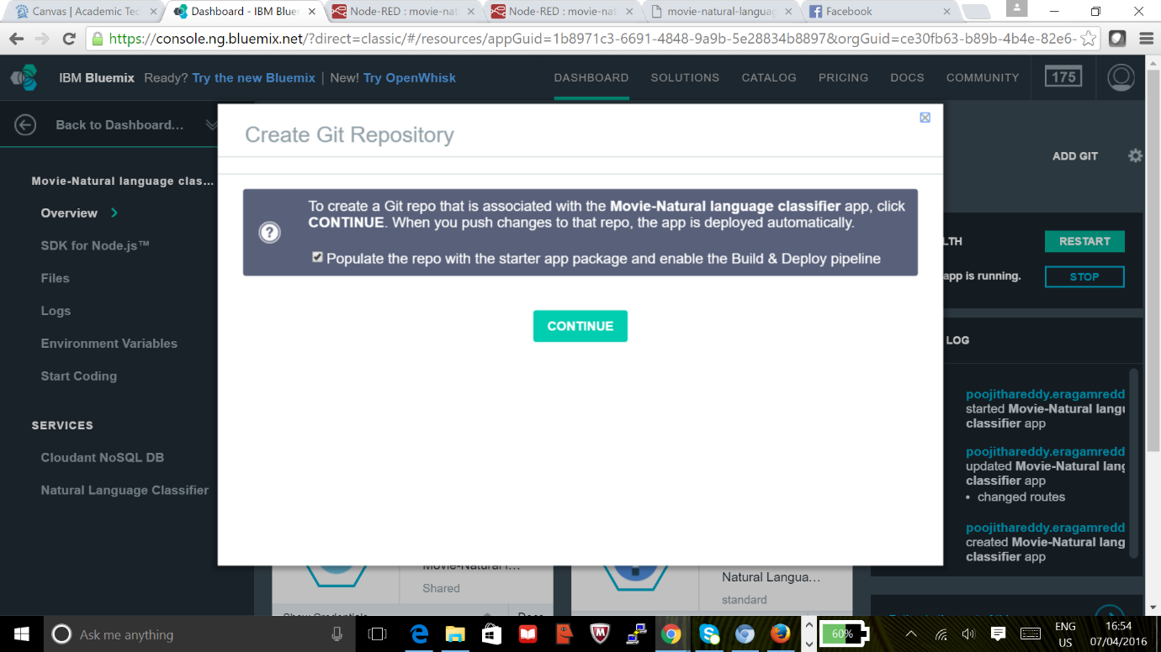

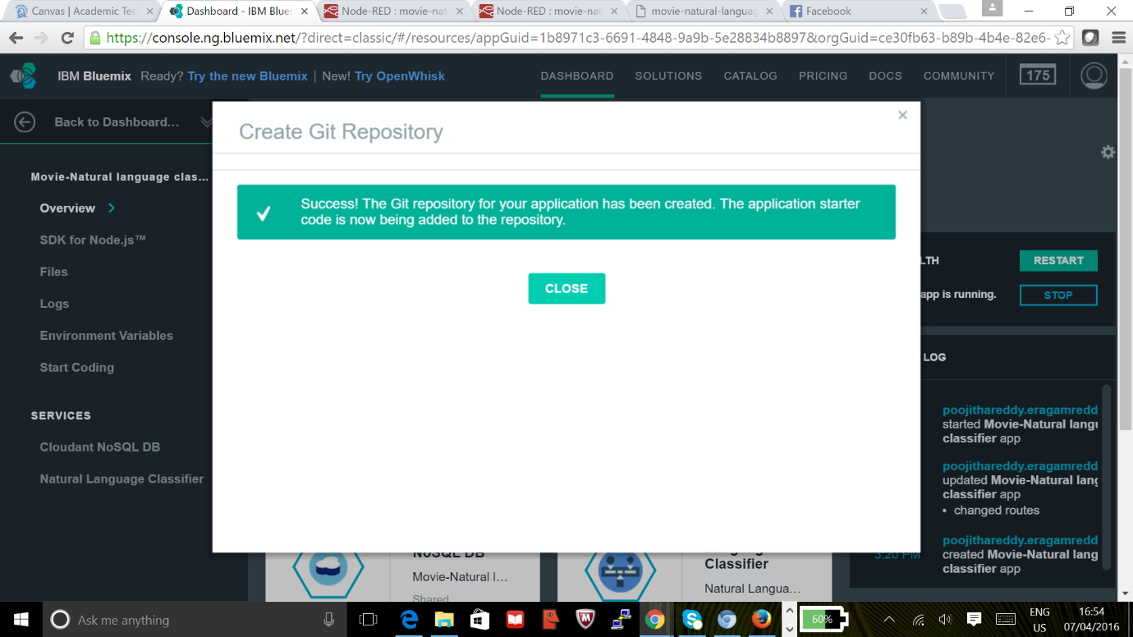

**Step 6: Deploy the application**

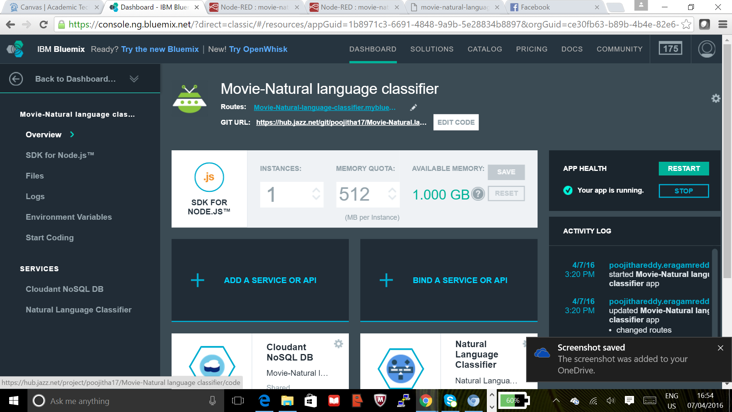

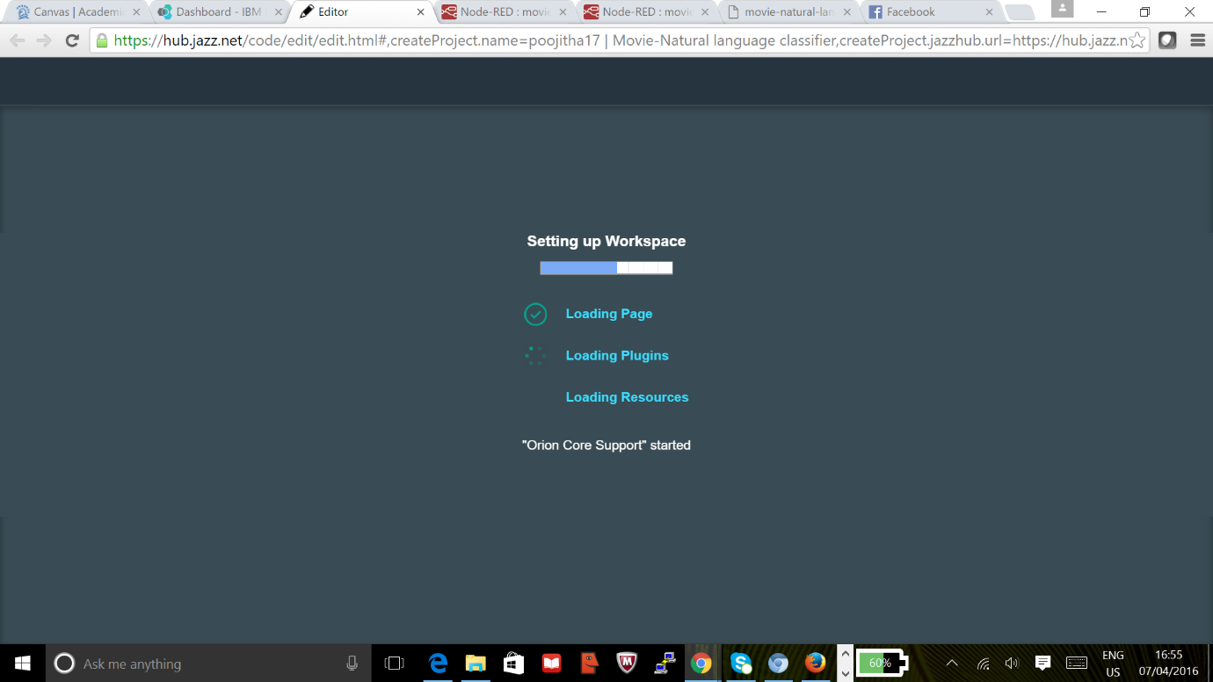

**6.1 Adding required files to the project and redeploying**

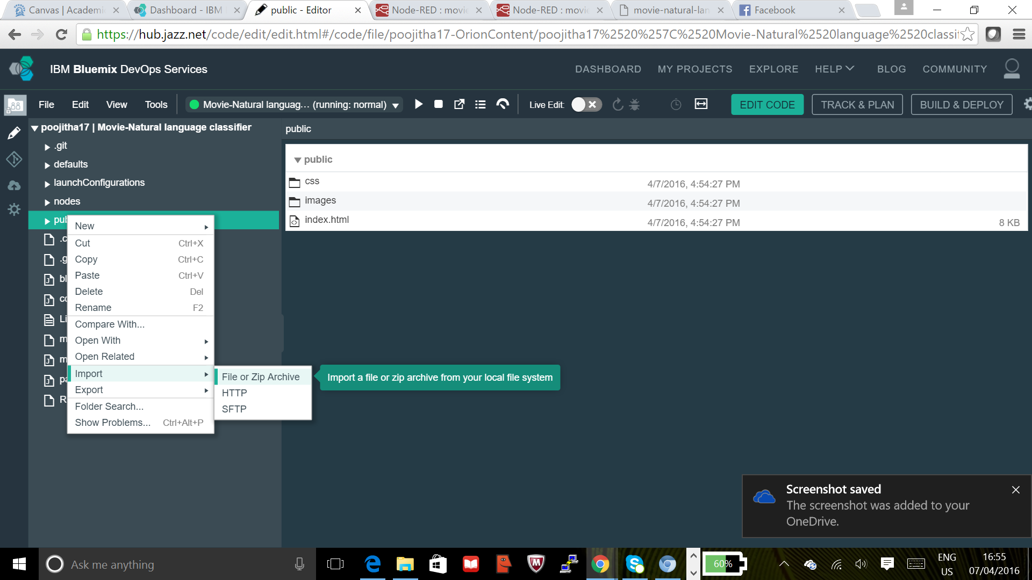

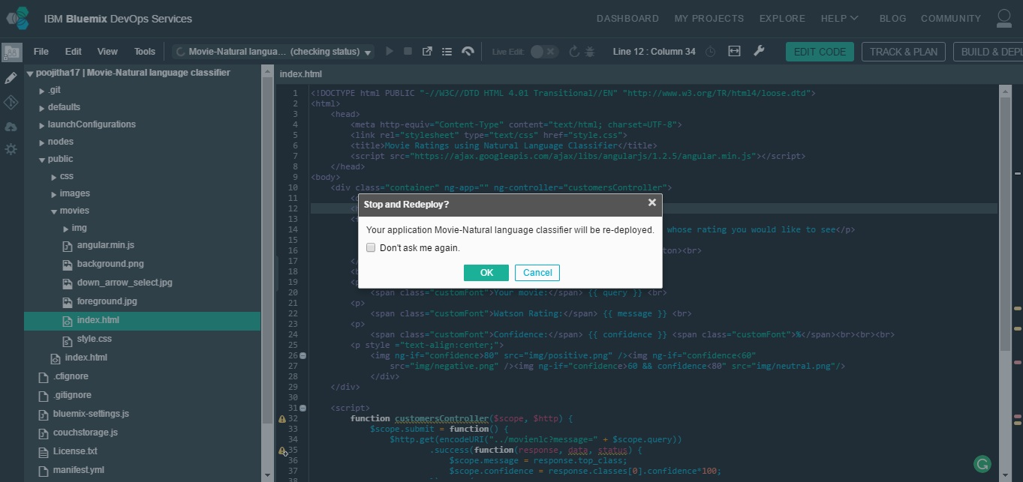

**Step 7: Web application output for movie The Oath, the images also change based on the confidence level of the classifier.**

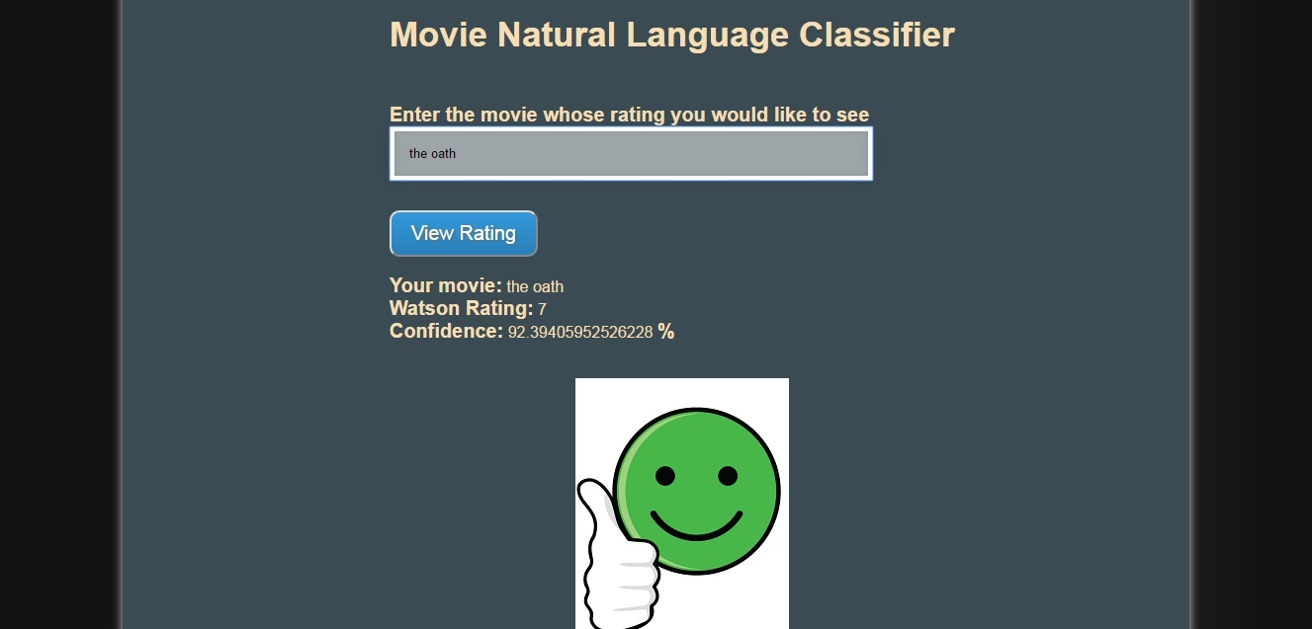

**Step 8: Confirm movie rating on IMDb**

